LHCb Collaboration | LHCb note 2001-023-Muon

6 March 2001

LHCb Muon System Gas System Proposal

F. Hahn, S. Haider, R. Lindner

Abstract
This document describes the gas system proposed for the LHCb Muon stations, following the Gas Working Group mandate to ensure the uniform approach to gas technology and controls across the LHC detectors.
Standard technical design modules are employed as far as possible, in order to minimise design overheads and long term support costs.

1 Introduction 1
2 Description of the Muon System 1
3 Muon Gas System 4
3.1 Mixer 6
3.2 Closed Circulation Loop 6
3.2.1 Pressure Regulation and Compressor 7
3.2.2 Gas Purification 7
3.2.3 Gas Distribution 7
4 Distribution Pipework 10
5 Gas Control 10

Introduction
The LHCb Muon system consists of five detector stations embedded in four iron shields with a thickness of 800 mm as shown in figure 2-1[1]. The first Muon station is positioned at 11920 mm from the interaction point, immediately in front of the calorimeter system. The allocated space between Muon station M2-M5 amounts to 400 mm, except station M1, which has to fit in the 370 mm between the tracker station T11 and the calorimeter system. The Muon system covers an acceptance of 300 mrad in the horizontal (bending) plane and 250 mrad in the vertical plane with an inner acceptance of 20 mrad x 16 mrad.

Figure 1-1: LHCb detector layout with Muon system

Description of the Muon System
Each Muon station is divided in four regions of granularity. Two detector technologies have been chosen, Multi Wire Proportional (MWPC) and Resistive Plate (RPC) Chambers. Region 3 and 4 of Muon station 4 and 5 are equipped with RPCs, while the MWPC are the preferred solution for the remaining part. For region one of station one (S1R1), where particle rates above 100 kHZ/cm2 are expected, the detector technology has not been defined at present.
The chambers will be mounted on panels (figure2-1), which are fixed to the support above the Muon system. Each station is divided vertical along the beam axis, which allows the displacement of the station transversal to the beam. The size [2] and gas volume of each chamber depending on its position in the Muon System is given in table 2-1. The total gas volume of the MWPC amounts to 4.5m³ and of the RPC chambers to 0.83m³.
Beam test results have shown that the preferred gas mixture for the MWPC consists of Ar-CO₂-CF₄ (40-50-10), whereas the RPCs will operate with a mixture of C₂F₄H₂-iC₄H₁₀-SF₆ in a non-flammable composition (95-4-1).

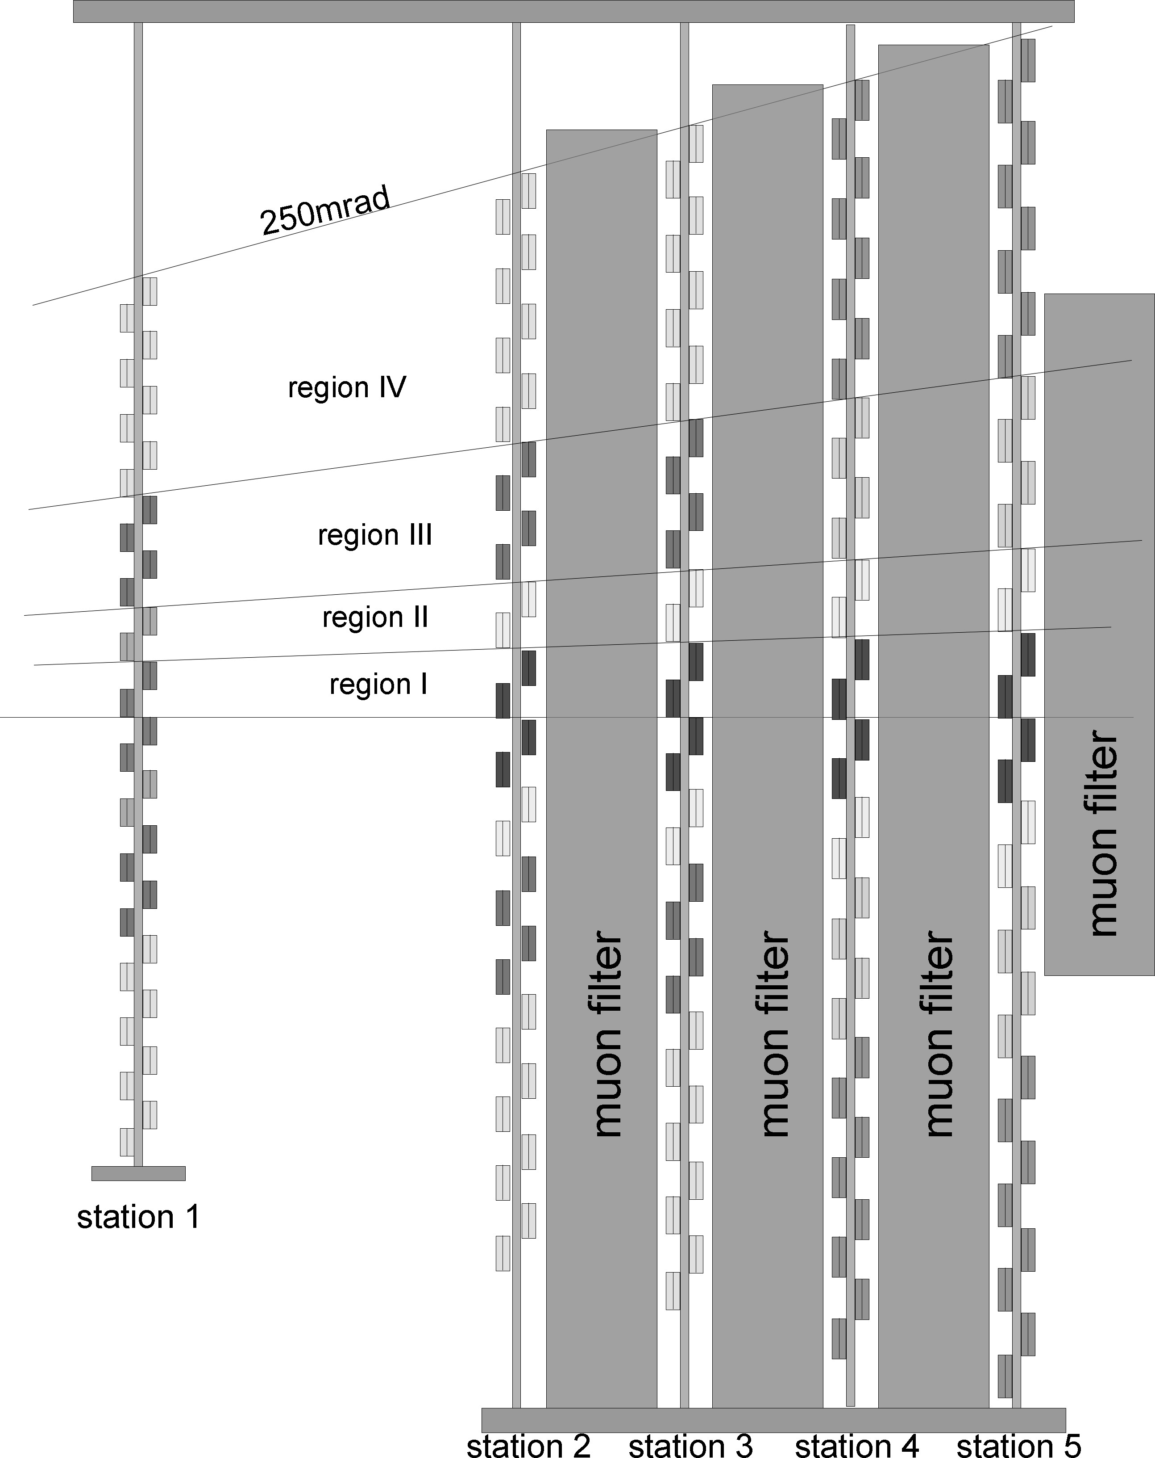

Figure 2-1 Muon System layout indicating the different regions in the five stations
Figure 2-2: Gas volume and size of each Muon chamber depending of the station and region

Muon Gas System
The basic function of the gas system is to mix the required gas components in appropriated proportions and to distribute the clean gas mixture into the individual chambers. A compilation of the basic parameters of both detectors concerning the gas system is listed in table 3-1.The high cost of CF₄ in the MWPC and C₂H₂F₄ in the RPCs makes a closed-loop circulation system compulsory. The system comprises a mixer and inside the circulation loop, the gas distribution, a pressure regulation and a purifier (Figure 3-1). The mixer and the purifier are located in the gas building at the surface, the pressure regulation will be placed in the experimental hall, behind the radiation shield. Distribution racks will be mounted close to the Muon System, attached to the detector support.

Detector | Gas | Volume | Flow rate | Regeneration  rate | Impurities max |  | Pressure | Pressure  max.
 |  |  |  |  | O₂ | H₂O
 |  | m³ | m³/h | % | ppm | ppm | mbar  above atm. | mbar
MWPC | Ar/CO₂/CF₄  50/40/10 | 4.5 | 0.375-0.75 | >90 | 50 | 50 | 1 | 5
RPC | C₂H₂F₄/i-C₄H₁₀/SF₆  95/4/1 | 0.83 | 0.07-0.14 | >90 | 10 | 10 | 1 | 3

Table 3-1: Basic gas parameters of the two muon systems

Figure 3-3 Schematic layout of the gas distribution system

Mixer

The gas mixer (Figure 3-2) will be build according to the LHC standard gas module design. It will mix the gas components in appropriate proportions, where each component will be metered by mass flow controllers. Process-control computers will monitor the flow of the gas, coming from the supply lines, and continuously calculate the correct mixture of the different gas components.
In addition, the fraction of i-C₄H₁₀ in the RPC gas mixture has to be controlled that the gas flow will be interrupt in case the flammability limit is passed. This assures that no flammable gas will reach the underground area. An infrared analyser will be placed after the mixer in order to perform the monitoring of the isobutane fraction in the gas mixture.

Figure 3-4: Gas Mixing Unit

Closed Circulation Loop

The Muon system gas is circulated in a close loop with an expected regeneration of 90%. The 10%, which will be replaced by the fresh gas, leave the gas system through possible leaks and through the exhaust line. The approximate gas exchange rate of one volume replacement will be between 6 and 12 hours, depending on the chamber position in a station. The oxygen and water content in the gas will be analysed before and after the purification.

Pressure Regulation and Compressor

A pump in the return line allows the gas to be compressed to approximately 300 to 500 mbar overpressure before returning to the gas building at the surface and cleaning through the purifiers. A back-pressure regulator in parallel with the pump controls the pressure to 0.5 mbar below atmospheric pressure at the inlet of the pump. Alternatively, a pump driven by a frequency regulator controlled by a pressure sensor on the detector could stabilise the pressure in the Muon system (Figure 3-4).

Figure 3-5: Pressure regulation system. (a) With frequency regulation (b) with back pressure regulator

Gas Purification

Closed loop gas circulation systems require gas purification in the return line from the detectors in order to archive high regeneration rates and low fresh-gas flows. The main impurities of concern, which accumulate in the system, are oxygen and water vapour, entering via joints and the detector sealing as well as at the entrance of the compressor where the pressure is very low.
A set of twin purifier cartridges (Figure 3-5) filled with two cleaning agents: molecular sieve (3Å) to remove the water vapour, and a second part activated copper as reducing agent for oxygen removal. The advantage of having two parallel cylinders in each cleaning stage is to run the gas mixture through on of the while the other one is being regenerated. Both agents in the same cylinder can be regenerated at the same time by heating the columns to 220C in 93% Ar and 7% H2 mixture. The operating cycle to clean the purifiers will be controlled by a process control computer, which allows exactly the same protocol to be followed each time.
The set of twin purifier cartridges will be placed at the surface in order to keep the underground as a non-flammable gas zone.

Gas Distribution
Each half Muon station will be supplied independently from the permanently accessible zone behind the radiation shield, thus allowing global flow control and pressure adjustments. Gas racks are mounted on the support structure of each half station for gas distribution to the individual chambers. From the distribution rack eight gas lines are connected to the chambers. In order to preserve redundancy in each station, two adjacent double-gap MWPCs and respective two single-gap RPCs are connected to a different gas supply line. Figure 3-4 shows the subdivision in eight separate gas zones in one half station. Chambers in one row in the same gas zone are in series and each row in the same gas zone is in parallel connected to one supply and return line.
The resulting gas volume per channel is given in table 3-2.

Station |  | 1 | 2 | 3 | 4 | 5
 | Region | Gas volume
Gas area |  | [l]
1 | 3 and 4 | 76 | 120 | 140 | 32 | 36
2 | 3 and 4 | 76 | 120 | 140 | 32 | 36
3 | 3 | 76 | 120 | 140 | 32 | 36
4 | 3 | 76 | 120 | 140 | 32 | 36
5 | 1 and 2 |  | 22.5 | 26.25 | 30.25 | 34.5
6 | 1 and 2 |  | 22.5 | 26.25 | 30.25 | 34.5
7 | 3 and 4 | 76 | 120 | 140 | 32 | 36
8 | 3 and 4 | 76 | 120 | 140 | 32 | 36
Table 3-2: Subdivision in different gas channels served by the same supply and return gas line for one half of a muon station.

Figure 3-6: Twin column purifier module with inline generation
Figure 3-7: The sketch shows one half of a Muon station. Gas supply and return lines are included for the layers of inner and upper part of one Muon half-station.

Distribution Pipework

All tubes and fittings will be made of stainless steel or copper, only the connection between the detector modules will be flexible plastic pipes. Existing pipes, used by DELPHI at point 8, from the mixer in the gas building at the surface down to the experimental cavern will be reused.
The gas racks will be placed on a platform above the SAS, which serves as passage through the radiation shield as can been seen at Figure 4-8. Muon station 1,2 and 3 will have one supply and one return line for each half station, whereas Muon station 3 and 4 will have two supply and two return lines for the two different gas systems. This results in 28 pipes between the area behind the shielding wall and the distribution racks on the detector.

Gas Control
The gas control will follow the general recommendations of the Joint-Control-Project of the four LHC experiments (JCOP). In particular, the production of gas control systems will be prepared using the industrial software development standard PSS05. In the first step of this framework, a User Requirement Document is prepared at the moment, which captures as many details as possible. The hardware architecture of the gas control equipment favours Programmable Logic Controllers (PLC) as front-end computers. This allows secure, standalone solution which are independent from generally used computer networks. Signals from sensors and actuators will be transmitted via a fieldbus to the PLCs. On a higher level, users will be able to interact with the gas control system via a Graphical User Interface dedicated for gas. Also here, general recommendations for SCADA systems from JCOP will be followed. This will ensure and facilitate the integration of the gas control system into the general LHCb Detector Control System.

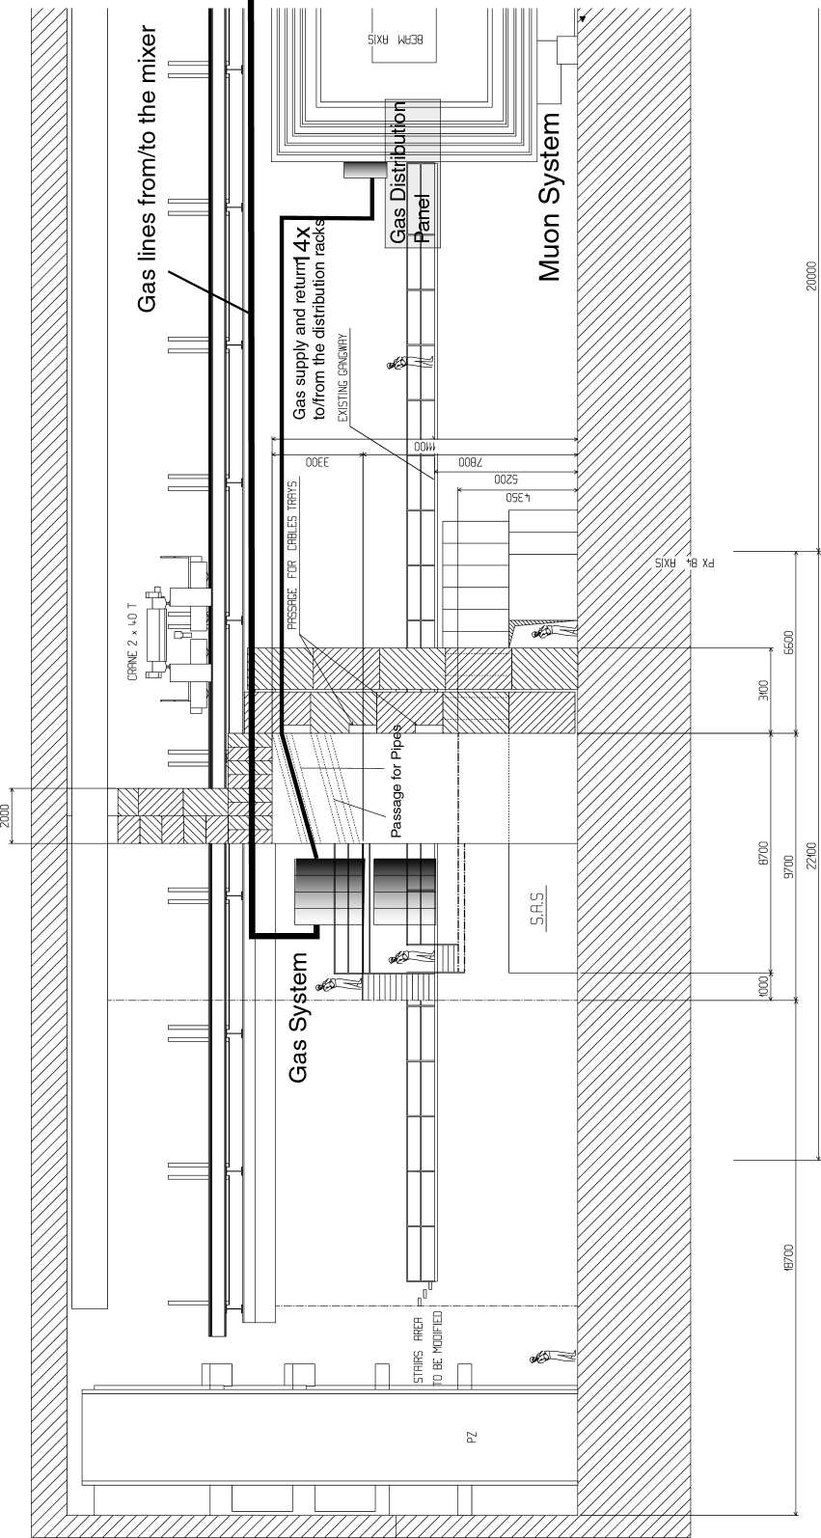
Figure 4-8: Distribution of pipe works in the UX cavern at point 8

